**Installation of XAMPP**

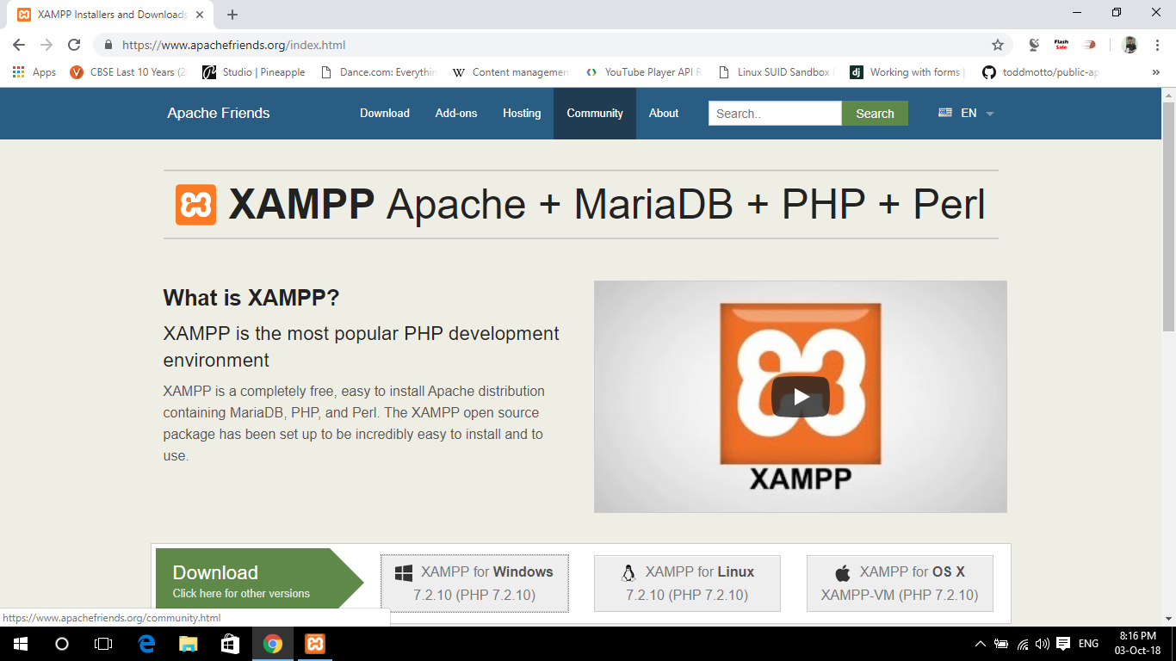

**Step 1:- Open the XAMPP website.** Go to <https://www.apachefriends.org/index.html> in your computer's web browser.

**Step 2:- Click XAMPP for Windows.** It's a grey button near the bottom of the page.

Depending on your browser, you may first have to select a save location or verify the download.

**Step 3:- Double-click the downloaded file.** This file should be named something like **xampp-win32-7.2.4-0-VC15-installer**, and you'll find it in the default downloads location (e.g., the "Downloads" folder or the desktop).

**Step 4:- Click Yes when prompted.** This will open the XAMPP setup window.

You may have to click **OK** on a warning if you have User Account Control (UAC) activated on your computer.

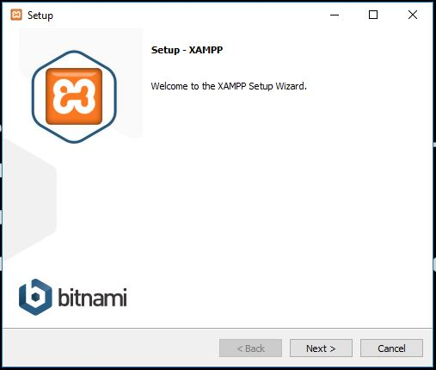

**Step 5:- Click Next.** It's at the bottom of the setup window.

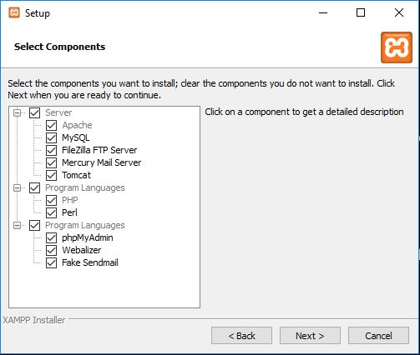

**Step 6:- Select aspects of XAMPP to install.** Review the list of XAMPP attributes on the left side of the window; if you see an attribute that you don't want to install as part of XAMPP, uncheck its box.

* By default, all attributes are included in your XAMPP installation.

**Step 7:- Click Next.** It's at the bottom of the window.

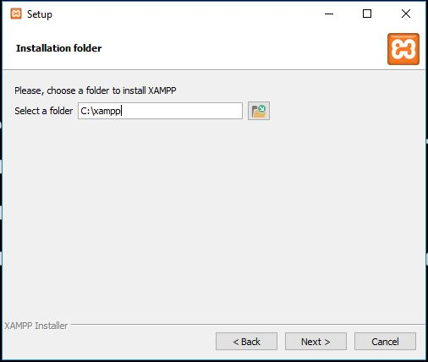

**Step 8:- Select an installation location.** Click the folder-shaped icon to the right of the current installation destination, then click a folder on your computer.

* If you have the UAC activated on your computer, avoid installing XAMPP in your hard drive's folder (e.g., **OS (C:)**).
* You can select a folder (e.g., **Desktop**) and then click **Make New Folder** to create a new folder and select it as the installation destination.

**Step 9:- Click Next.** You'll find it at the bottom of the page.

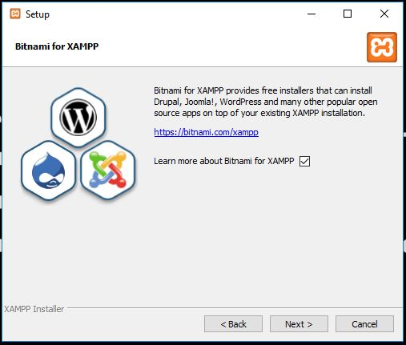

**Step 10:- Click Next.** You'll find it at the bottom of the page.

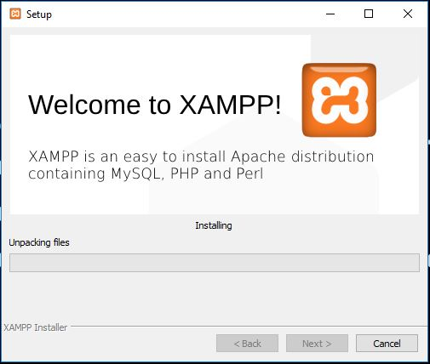

**Step 11:- Begin installing XAMPP.** Click **Next** at the bottom of the window to do so. XAMPP will begin installing its files into the folder that you selected.

**Step 12:- Start XAMPP from its installation point.** If you need to open the XAMPP Control Panel in the future, you can do so by opening the folder in which you installed XAMPP, right-clicking the orange-and-white **xampp-control** icon, clicking **Run as administrator**, and clicking **Yes** when prompted.

* When you do this, you'll see red **X** marks to the left of each server type (e.g., "Apache"). Clicking one of these will prompt you to click **Yes** if you want to install the server type's software on your computer.
* Counterintuitively, double-clicking the **xampp\_start** icon doesn't start XAMPP.

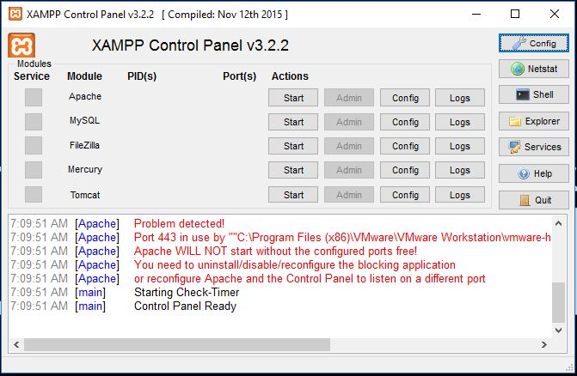

**Step 13:- Resolve issues with Apache refusing to run.** On some Windows 10 computers, Apache won't run due to a "blocked port". This can happen for a couple of reasons, but there's a relatively easy fix:[[1]](https://www.wikihow.com/Install-XAMPP-for-Windows" \l "_note-1)

* Click **Config** to the right of the "Apache" heading.
* Click **Apache (httpd.conf)** in the menu.
* Scroll down to the "Listen 80" section (you can press Ctrl+F and type in listen 80 to find it faster).
* Replace 80 with any open port (e.g., 81 or 9080).
* Press Ctrl+S to save the changes, then exit the text editor.
* Restart XAMPP by clicking **Quit** and then re-opening it in administrator mode from its folder.

**Using MariaDB using XAMPP**

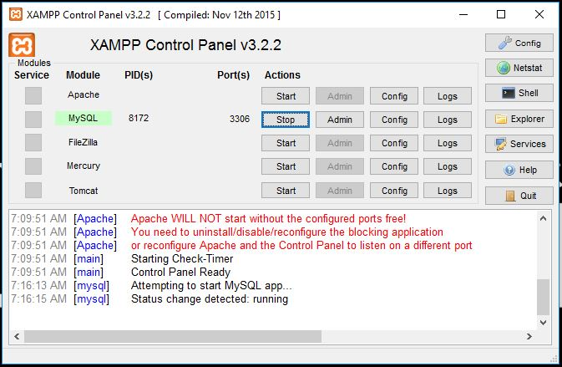

**Step 1:- Open XAMPP Control Panel and then click on Start Action of MySQL service.**

**Step 2:- After Starting MySQL service Click on Shell on the Control Panel. On Clicking shell button a you will get a shell.**

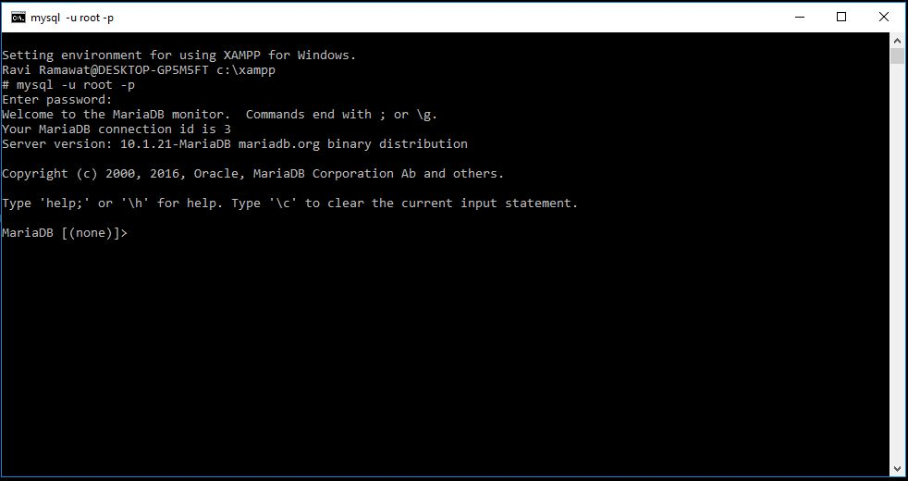

**Step 3:- Now you have to login to create a database**

**Command :- mysql –u root –p**

**If it ask for password then press Enter.**

**Commands for Using and Creating Database**

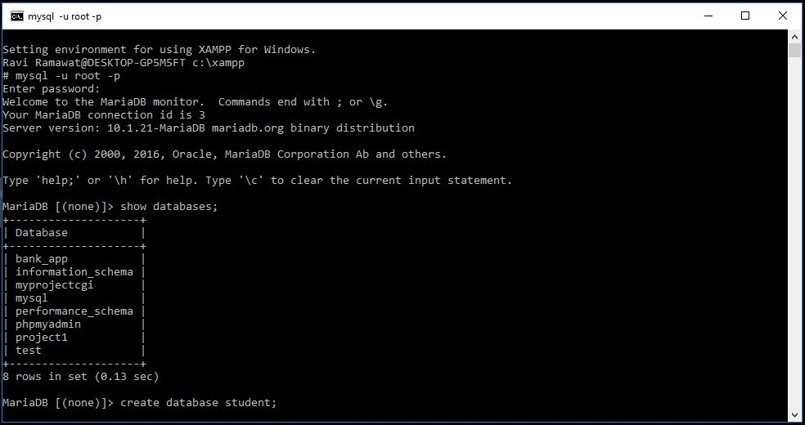

**To show databases Run Command :- show databases;**

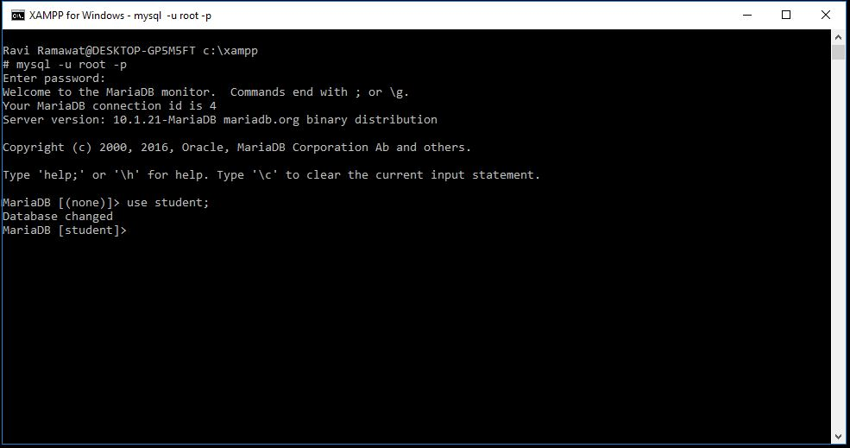

**To use Database run command :-**

**use database\_name;**

**Example:-**

**use student;**

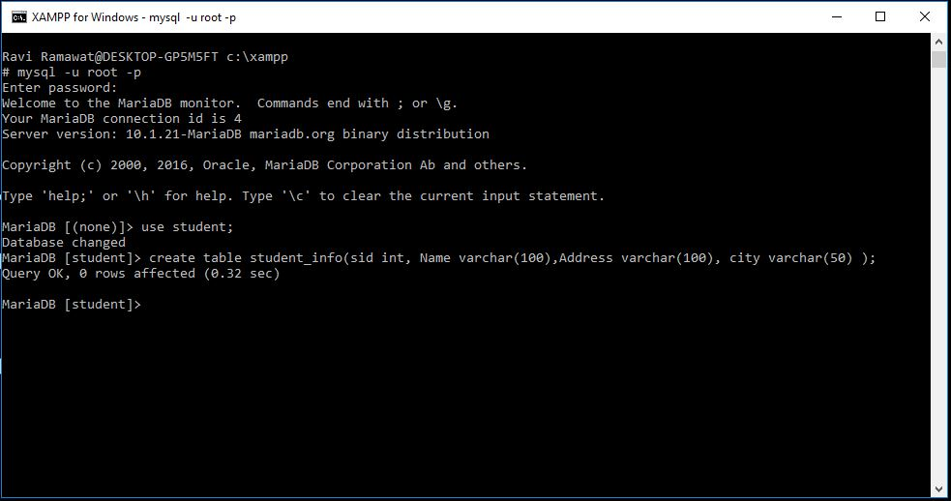

**Command to Create Table:-**

CREATE TABLE table\_name (  
    column1 datatype,  
    column2 datatype,  
    column3 datatype,  
   ....  
);

**Example:-**

CREATE TABLE student\_info (  
    SID int,  
    Name varchar(255),  
    Address varchar(255),  
    City varchar(255)   
);

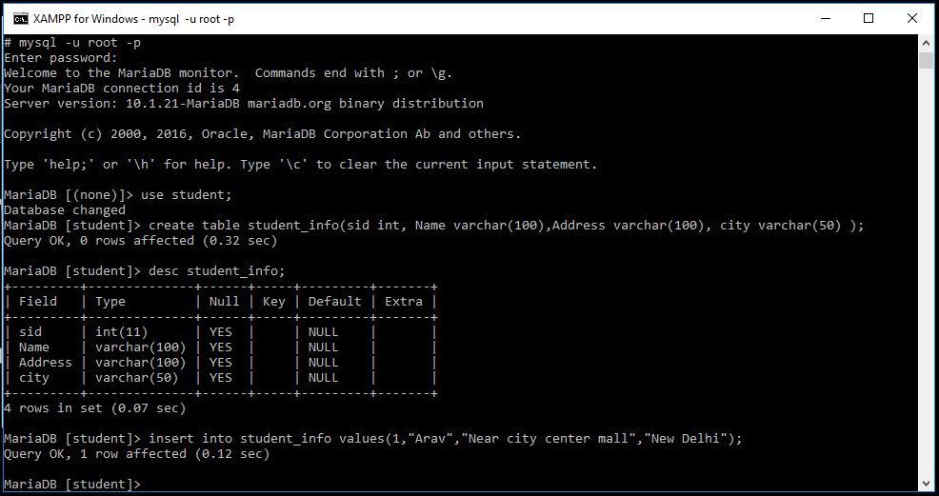

**Command to insert values in a table:-**

INSERT INTO tablename values(value for ID, Name, Address, City);

**Example :-**

INSERT INTO student\_info values(1, “Raj”, “Kukas”, “Jaipur”);

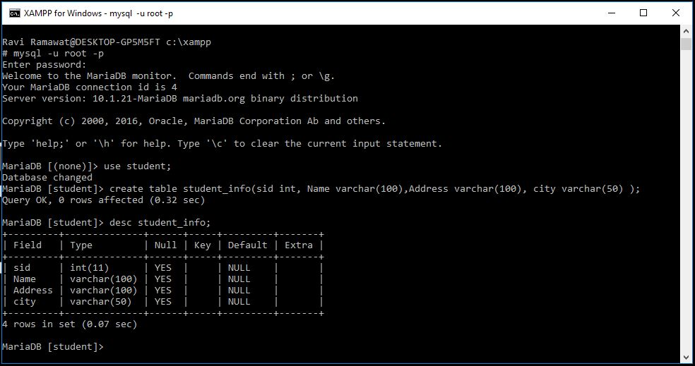

**Command to see table Description :-**

desc table\_name;

**Example:-**

desc student\_info;

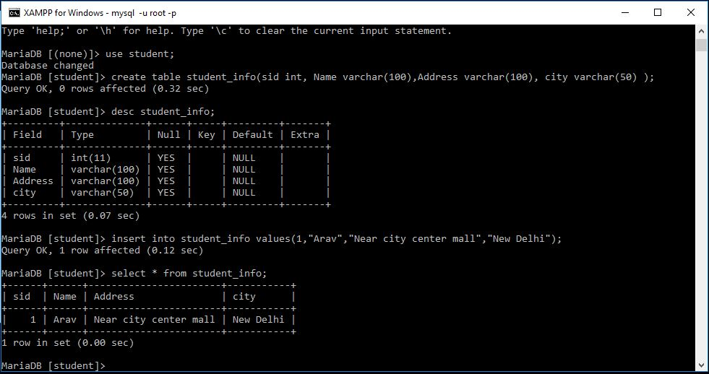

**To see entered data of a table :-**

Select \* from table\_name;

**Example:-**

Select \* from student\_info;

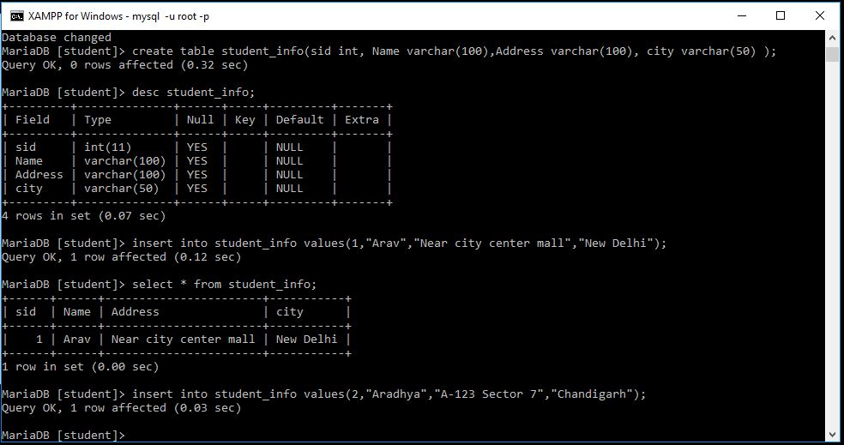

**Similarly we can insert data in table as mentioned above.**

